|  |  |  |  |  |  |  |
| --- | --- | --- | --- | --- | --- | --- |
| https://sia.mercubuana.ac.id/application/akad/assets/images/mercubuana.jpg | **ANSWER SHEET** | | | | | https://sia.mercubuana.ac.id/application/akad/assets/images/mercubuana2.jpg |
| Semester : Odd / **Even** / Short*) Academic Year : 2020/2021 | | | | |
|  |  |  |  |  |
|  |  |  |  |  |  |  |
| Student Number | | 41518010056 | | Exam No.: | 3 | Student Signature |
| Name |  | Yeppy Mangun Puspitajudin | | | |  |
| Faculty / Study Program | | Computer Science / Informatics | | | | Lecturer Signature |
| Course |  | INTRODUCTION TO CLOUD COMPUTING | | | |  |
| Lecturer |  | Arif Rifai Dwiyanto, ST, MTI, CISA | | | | Score (00-100) |
| Time of Exam |  | Day | Date | Time | Room |  |
|  |  | Thursday | 08 July 2021 | 07:30-10:00 | I-404 |  |

1. **Cloud Computing Definition, Benefits, How it Works, and Examples**

**Definition**

Cloud computing is the technological capability to use IT infrastructures and services that are not installed on a local computer or server. Using a network (Internet or Intranet), connections are made to external computers or servers that provide appropriate resources. These services are both provided and used exclusively via technical interfaces, protocols or browsers.

The applications are located outside of the central infrastructure – floating around the company, you could say – hence the cloud metaphor.

**Benefits**

* Reduced IT costs

Moving to cloud computing may reduce the cost of managing and maintaining your IT systems. Rather than purchasing expensive systems and equipment for your business, you can reduce your costs by using the resources of your cloud computing service provider.

* Scalability

Your business can scale up or scale down your operation and storage needs quickly to suit your situation, allowing flexibility as your needs change. Rather than purchasing and installing expensive upgrades yourself, your cloud computer service provider can handle this for you. Using the cloud frees up your time so you can get on with running your business.

* Business continuity

Protecting your data and systems is an important part of business continuity planning. Whether you experience a natural disaster, power failure or other crisis, having your data stored in the cloud ensures it is backed up and protected in a secure and safe location.

* Collaboration efficiency

Collaboration in a cloud environment gives your business the ability to communicate and share more easily outside of the traditional methods. If you are working on a project across different locations, you could use cloud computing to give employees, contractors and third parties access to the same files.

* Flexibility of work practices

Cloud computing allows employees to be more flexible in their work practices. For example, you have the ability to access data from home, on holiday, or via the commute to and from work (providing you have an internet connection).

* Access to automatic updates

Access to automatic updates for your IT requirements may be included in your service fee. Depending on your cloud computing service provider, your system will regularly be updated with the latest technology.

**How it works?**

To understand the workings of a cloud system, it is easier to divide it into two sections: the front end and the back end. They are connected to each other through a network, usually the Internet. The front end is the side of the computer user or client. The back end is ‘the cloud’ section of the system.

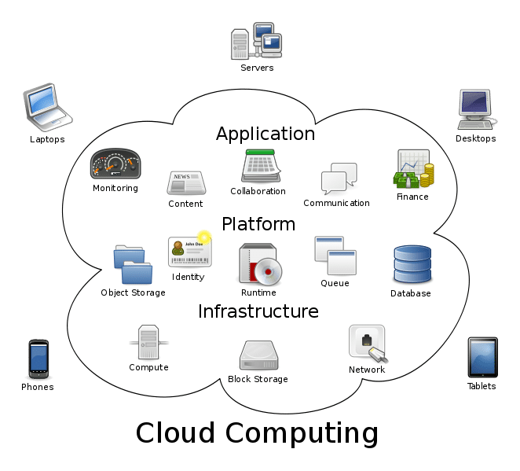

The front end consists of the client’s computer or computer network. Also the application essential to access the cloud system. It is not necessary that all cloud computing systems have the same user interface. On the back end of the cloud technology system, there are various computers, servers and data storage systems that make up the cloud. A cloud computing system could potentially include any computer program, from data processing to video games. Generally, each application will have its own dedicated server.

**Examples**

**SaaS or Software as a Service.** SaaS means instead of installing software on your computer, you access the platform online. Examples would include:

* com, which hosts sales information and databases online
* Square, which processes payments online
* Google Apps such as Google Drive or Calendar
* Slack, which allows collaboration and chat between other users

**IaaS or Infrastructure as a Service**. IaaS provides infrastructure components such as servers, storage, networking, security, and moreover the cloud. Examples would include:

* Dropbox, a file storage and sharing system
* Microsoft Azure, which offers backup and disaster recovery services, hosting, and more
* Rackspace, which offers data, security, and infrastructure services.

**PaaS or Platform as a Service**. PaaS provides computing platforms such as operating systems, programming language execution environments, databases, and web servers. Examples would include:

* Google App Engine and Heroku, which allow developers to develop and serve apps

**Serverless Computing**. Serverless computing (also called simply “Serverless”) is simply using a server on the cloud. This offers more elasticity, easier maintenance, and is often more price effective than hosting servers on-site.

1. **Problem in companies that can be solved by using Cloud Computing**

**Problem**

I’ve heard that many start-up company, they faced the problem about maintaining security on their platform especially they had limited technical support (does not have proper IT people to handle).

**Solution**

So someone proposed a solution to try out about cloud computing. Which analysed can solve:

1. Limited Technical Support

Outside the cloud, the organization is limited to whoever is working inside the office. In the case of an emergency, they either have to hope their local professionals can get the job done or hire a third-party company to help, which could be costly.

This risk is reduced in the cloud because we’ll have the built-in support of experienced professionals, and we won’t have to rely on anyone with minimal experience.

Moving to the cloud may seem complicated at first, but the transition can help mitigate a series of long-term problems. The use of public and hybrid cloud services is becoming the new norm.

1. Reduce Security Risk

Cloud technology has advanced greatly and now it is actually more secure and reliable than traditional on premise solutions.  In fact, 64 percent of enterprises report that the cloud is more secure than their previous legacy systems, and 90 percent of businesses in the USA are currently utilizing a (hybrid) cloud infrastructure.

Many business owners who are accustomed to using local servers hesitate to transition to the cloud for fear of security risks. They worry that having their information “out there” on the cloud will make it more susceptible to hackers.

As scary as these fears are, however, they are unlikely to happen. In fact, your data is just as secure in the cloud as it is in bare metal servers. Because cloud hosting has become so popular, it has quickly progressed to the advanced stages of security. In other words, because so many businesses are using cloud hosting in some form, it has been forced to maintain high levels of security to meet all the demand.

1. **Benefit of Virtual Private Server (VPS).**

**1. Increase Website Reliability and Performance**

On a shared server, the activities of other customers can have an impact on your website. If another site gets a sudden jump in traffic, for example, our site may experience performance issues.

Slow loading times are a problem, because they drive visitors away and can negatively impact our conversions. What’s more, we may also have to contend with security issues, since a hacked website is a risk to all other sites on the same server.

On the other hand, a VPS provides an environment and resources that are specifically for our website and no one else. Traffic from other websites will no longer be your concern, and our site will be safely sectioned off in its own space. These factors can play a huge role in ensuring that our site provides a reliable experience for visitors.

**2. Use the Your Resources as We See Fit**

Thanks to the dedicated resources a VPS provides, we are free to use them however we need. This is another big distinction between this kind of plan and shared hosting, where we have little control over how resources are allocated.

When we sign up for a VPS, we will know exactly what resources we have, and be able to use them exclusively for content and manage them as needed. This also makes it a lot easier to run more than one website on the same plan.

Another related benefit is that we are not constrained by a single physical server. Therefore, it’s easier to expand our resources along with our site’s requirements.

**3. Install Only the OS and Software We Are Going to Use**

Shared hosting offers very little choice when it comes to configuring the server. Since the web host manages it exclusively, they choose the applications and OS they want to use. In fact, we may not even know how the server is set up on this type of plan.

VPS plans, on the other hand, often provide choices depending on our needs. Many of them will give us various OS options, as well as an auto installer for common development applications. Some unmanaged plans even provide complete freedom over installation and administration.

All in all, a VPS is especially helpful for web developers. For example, we will be able to choose the version of PHP that we prefer, or employ node.js for our web development project. We can also uninstall the applications we don’t needed, freeing up additional server resources.

1. Cloud Computing Architecture / Topology

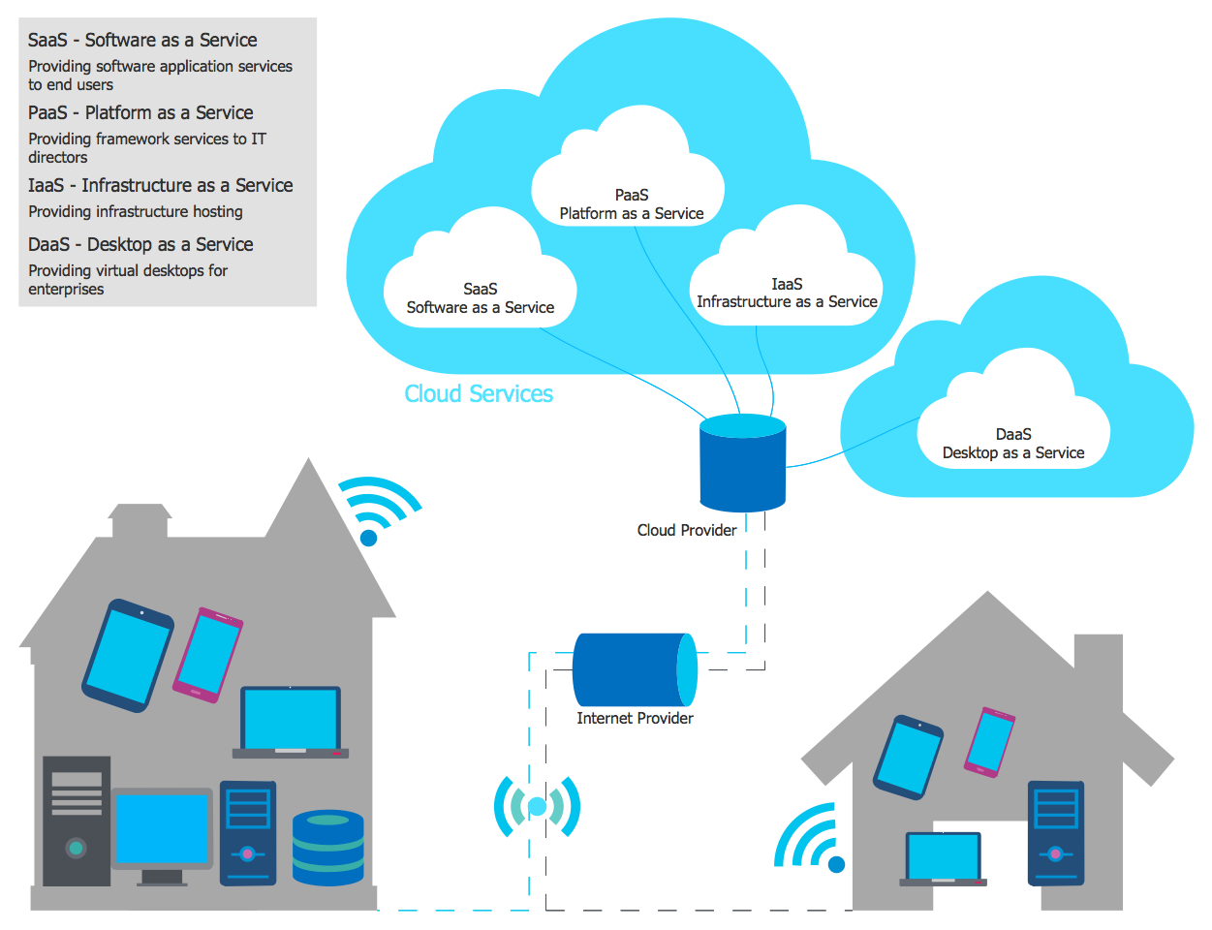

The diagrams and schemes above visualize the differences architectures types and how Cloud computing works. There is 4 architectures, include SaaS, PaaS, IaaS and DaaS which explained in above image. And each architectures can be used in office as company infrastructure, or in home as private server maybe.

And here are the example of GitHub, that use SaaS architecture.

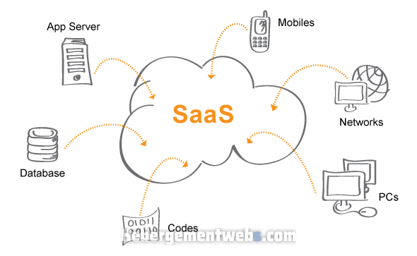

GitHub is a web-based version-control and collaboration platform for software developers. GitHub, which is delivered through a software-as-a-service (SaaS) business model, that provides the git version control software, along with space to store code, and social networking functionality.

1. Self-Hosted NextCloud using Kubernetes as SaaS Private Cloud.

Here is the link of my works:

<https://youtu.be/DXtcSm4ZgYU>

Kubernetes (K8S) is an open-source system for automating deployment, scaling, and management of containerized applications. It is neither IaaS or PaaS, kubernetes is like a container orchestration engine which makes it more like a Container As A Service or CaaS. So, we will create our home-lab cloud in this system.

1. **Installation**

Before installing the Kubernetes, we have to install Kubectl and Minikube first. Kubectl is command-line tools to control the Kubernetes. It allows us to perform every possible Kubernetes operation, on the other word, kubectl is a client for the Kubernetes API. Minikube is a utility you can use to run Kubernetes on our local machine. It creates a single node cluster contained in a virtual machine (VM). This cluster lets us do demo Kubernetes operations without requiring the time and resource-consuming installation of full-blown K8s.

1. **Install kubectl**

In my Mac, I use HomeBrew so the installation is using this command:

*brew install kubectl*

After installed, if we want to make sure check kubectl version by this command:

*kubectl version --client*

1. **Install minikube**

Each machine has different capabilities, especially virtualization process, to verify virtualization possibility on my mac, I will use hyperkit

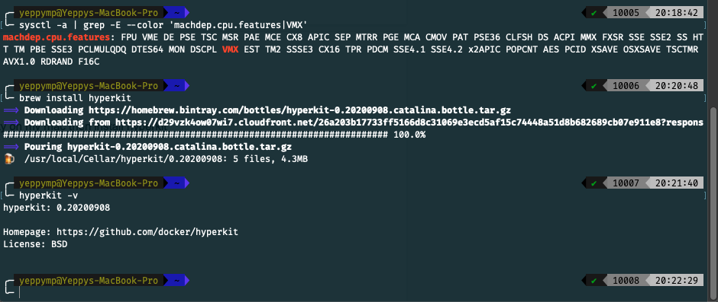

Then if it possible, then installing minikube:

*brew install minikube*

1. **Configuration**

The next step is installing NextCloud as SaaS below kube

**Starting the Minikube**

It takes a lot of time, because it has to download the minikube iso, and k8s image that almost takes 1GB.

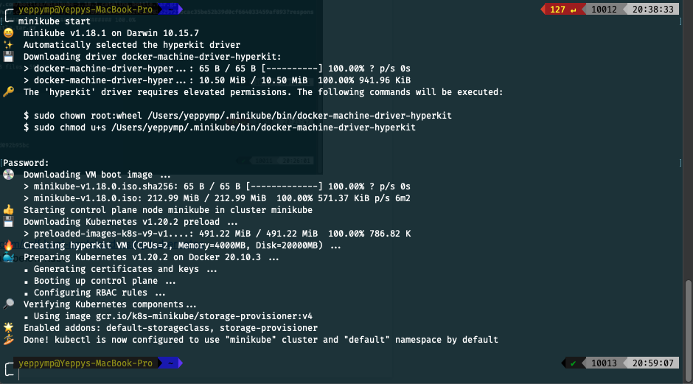

**Setting the NextCloud**

NextCloud has two main components: a server container and a database container. First, we will start by going over the database:

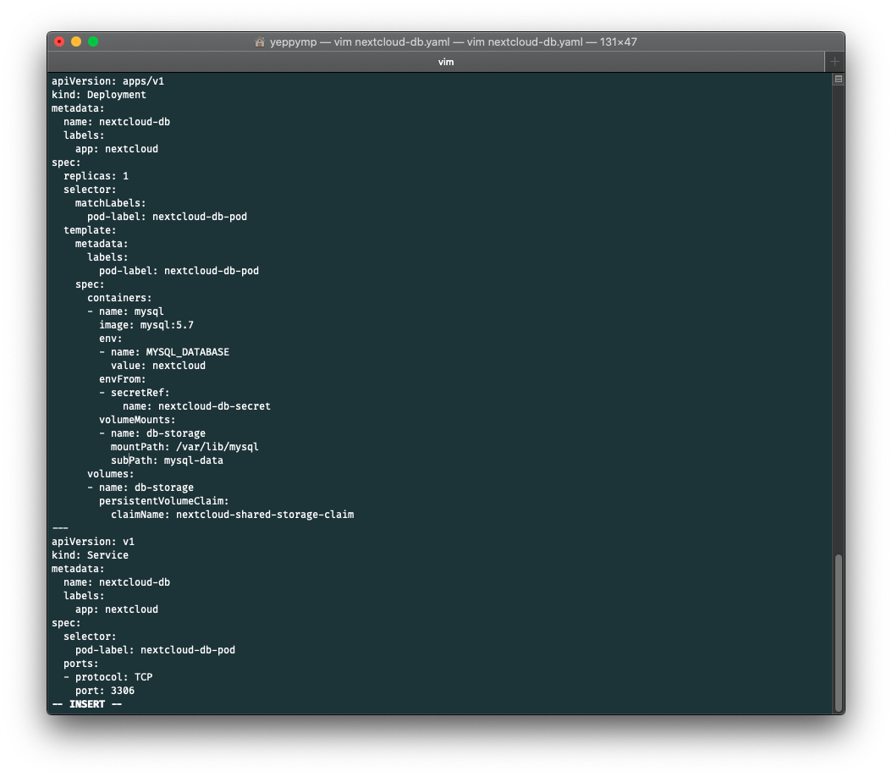

Here, I set some of the values, first is name our Kubernetes deployment, I name it nextcloud-db. The purpose of this is to make sure that the database will run all the time. Next is the replicas, it is used when the node gets some error and cannot be used, the deployment will create the replacement. There is also in spec: containers, it defines the mysql version that I will use.

**Kube volumes**

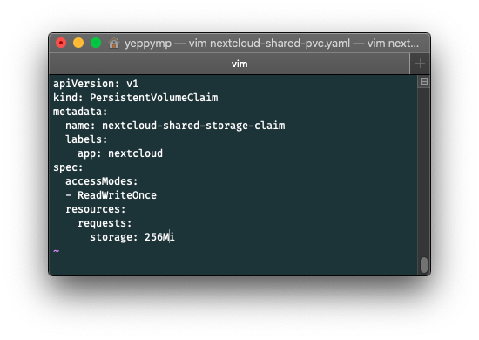

The volumes are used when the container terminates, because when it happens, everything that is stored in the container will be gone. The volumes are designed for durable storage to containers.

**Create MySQL Database Component**

First, I have to create/apply the persistent volume claim using this command below:



After that, create/apply the Database deployment and service.

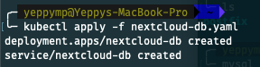

**NextCloud Server Deployment**

After the database is running, the next step is to create the Kubernetes config files for the nextcloud server components.

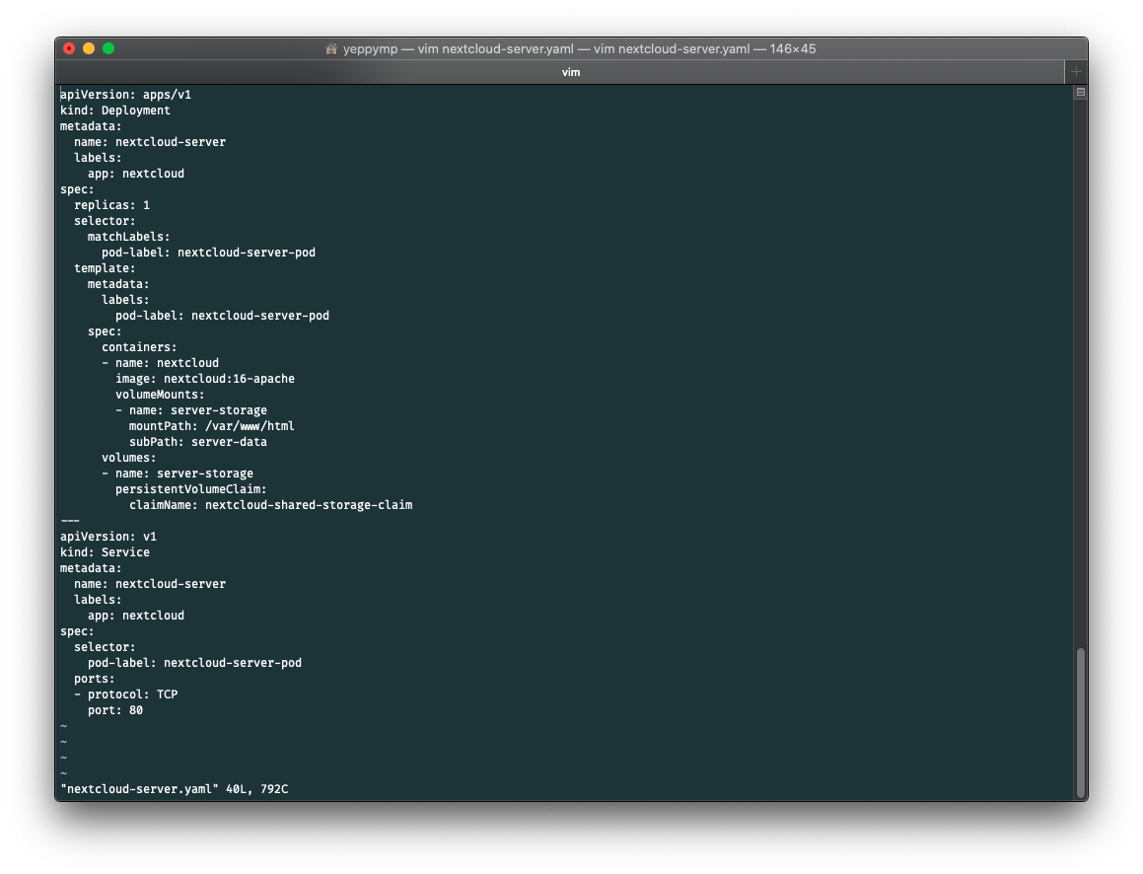

**Create/Apply NextCloud Server**

To create the NextCloud server development and service, run this command in the same directory as before.

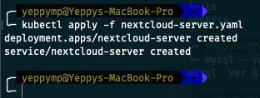

**Kubernetes ingress**

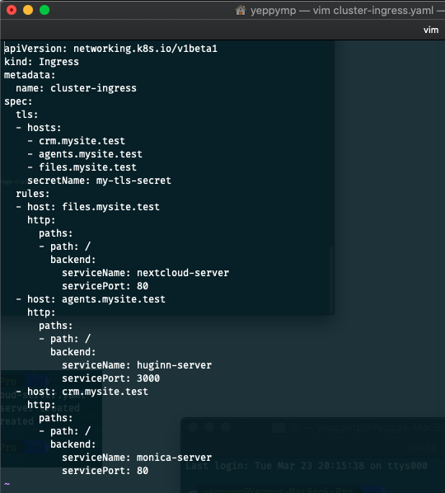

What I am going to do right now is configure the database-related environment variables on the NextCloud web page. First thing that we have to do is make the NextCloud server browser-accessible. By default, clients outside of the cluster cannot communicate with pods inside of the cluster. The way that we are going to solve this is by creating a Kubernetes Ingress object. It will allow external clients to connect with the NextCloud server in our cluster.

**Enable Ingress Addon**

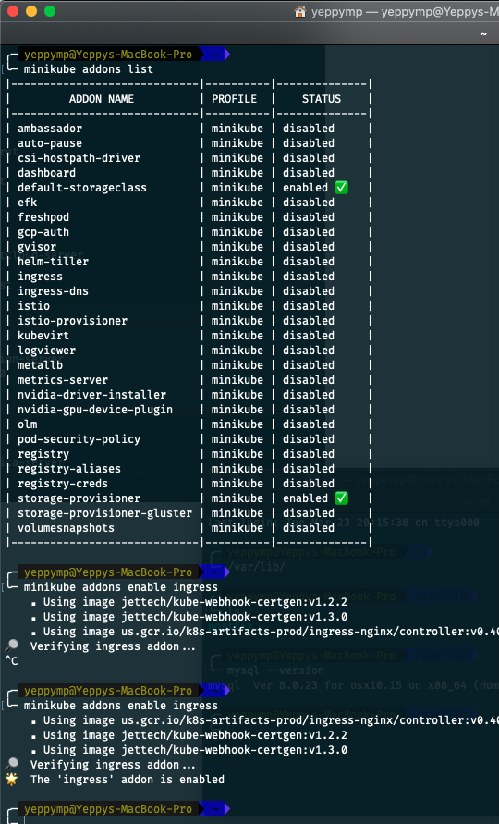

For creating the ingress object, I have to enable the ingress on the cluster, because the ingress is disable by default. For doing it, I use the commands above.

**Create ingress object**

To create/apply the ingress object, use same command as before

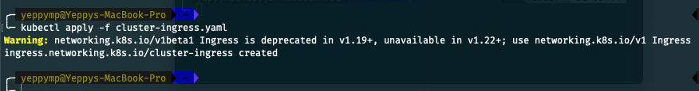

**Update host file**

I have to map the IP address to my minikube node. Because when I did not do that, it would show a 404 error because there is nothing there.

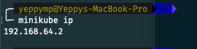

Editing host and add kube ip to host files.mysite.test

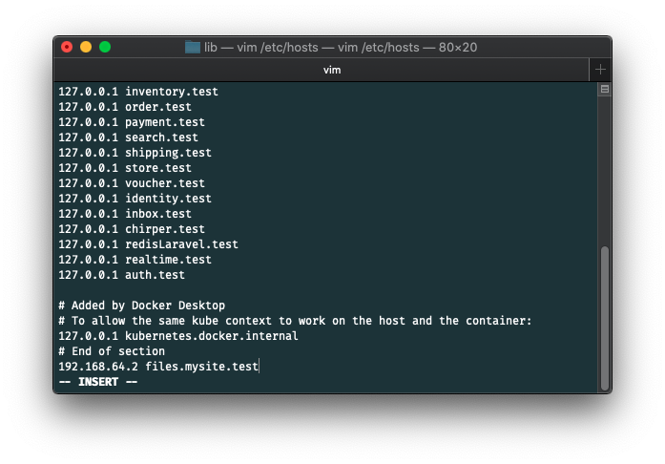

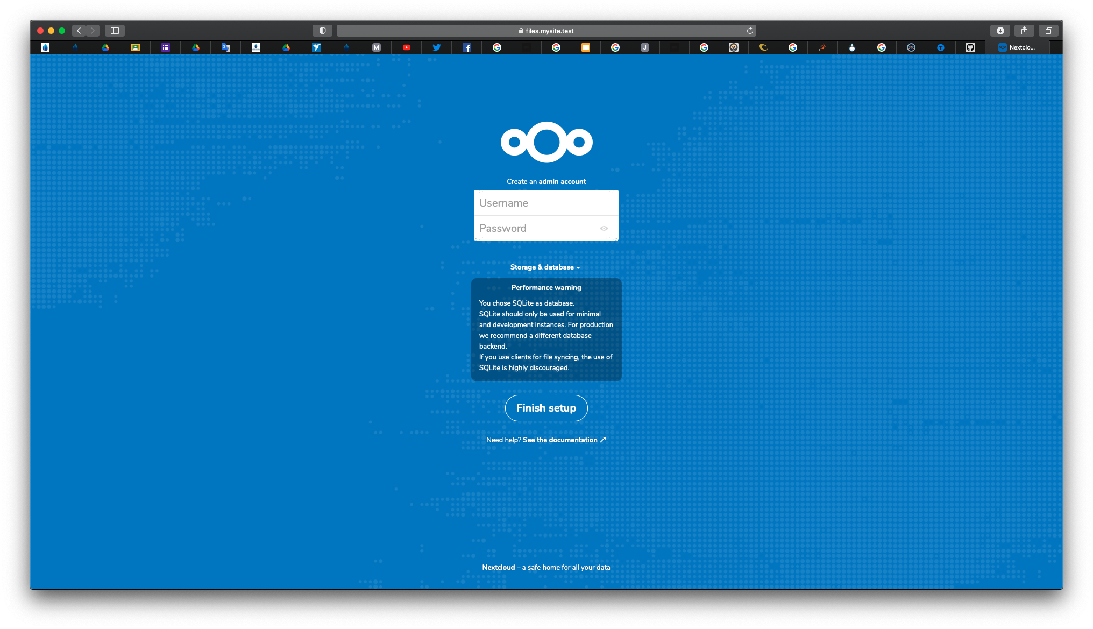  
Now nextcloud can be accessed on my local connection (Private) using files.mysite.test. Above is when I access it on my laptop.

1. **Conclusion**

So that is how to setup self-hosted NextCloud under kubernetes, nextcloud as SaaS, and kubernetes either as PaaS or LaaS. Well now I have a private cloud on my laptop, this report just until kubernetes & nextcloud are ready to use, for application deployment we need some more steps, which configuring database, storage, domains etc. It is like some basic setups in hosting while we are going to deploy our application.